Dashboard
A dashboard is a graphical user interface (GUI) that displays information and data in an organized, easy-to-read format. Dashboards are often used to provide real-time monitoring and analysis of data and are typically designed for a specific purpose or use case. Dashboards can be used in a variety of settings, such as business, finance, manufacturing, healthcare, and many other industries. They can be used to track key performance indicators (KPIs), monitor performance metrics, and display data in the form of charts, graphs, and tables.

Dashboard 1

Dashboard 1: UNESCO World Heritage Site Overview
Link: https://drive.google.com/file/d/1wjQb6BoHlfT3wyKEEBcMeSTBEzoHAmjk/view?usp=sharing
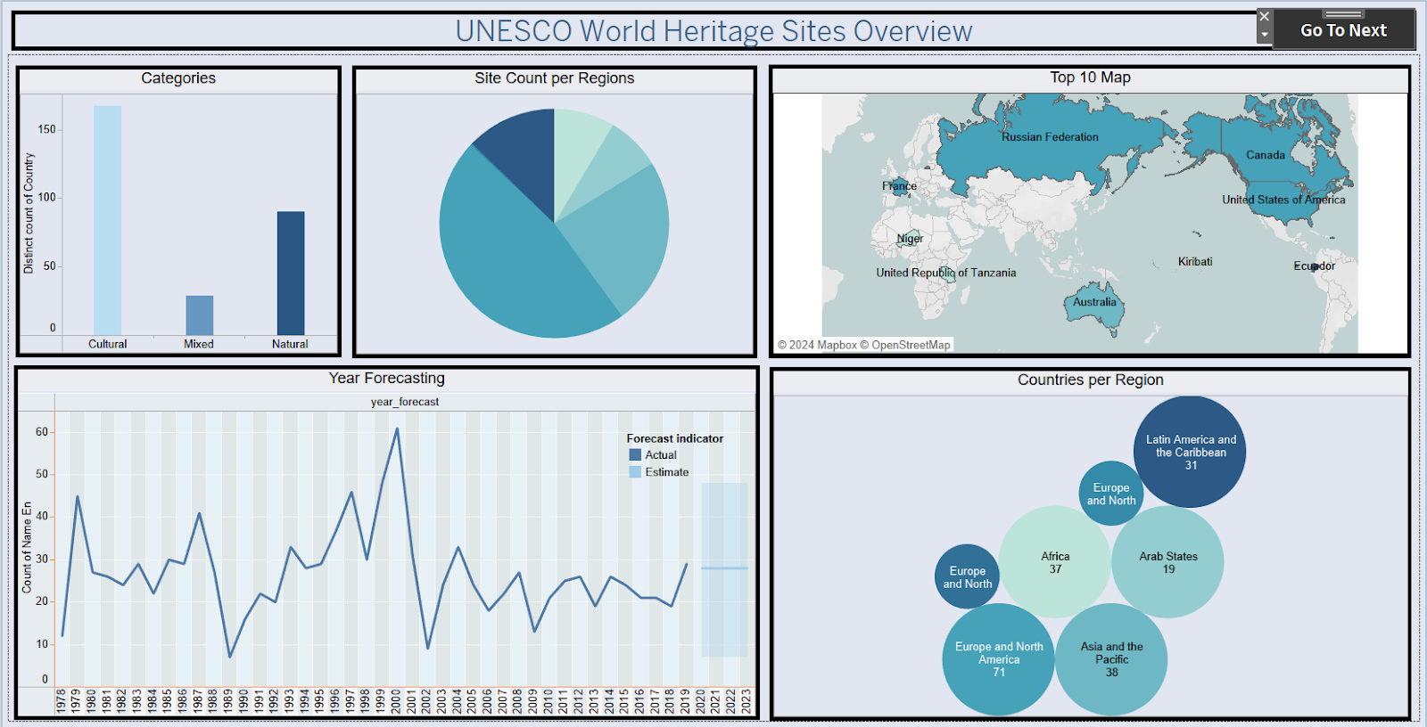

Dashboard 2: Link: https://drive.google.com/file/d/1PS7vZLeCV52n7hruFeN1IAHBJ8fTssUr/view?usp=sharing
